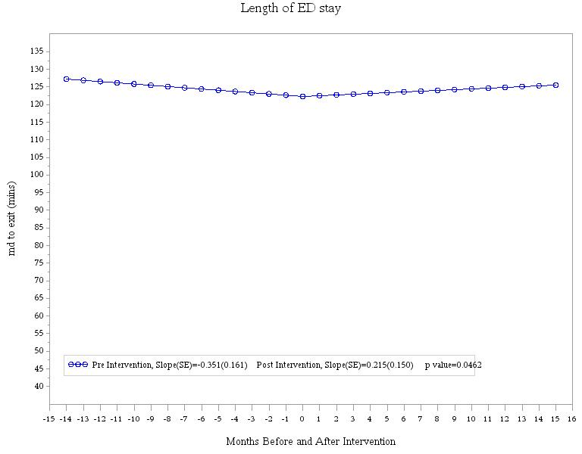

Y-axis title: Length of stay (min)

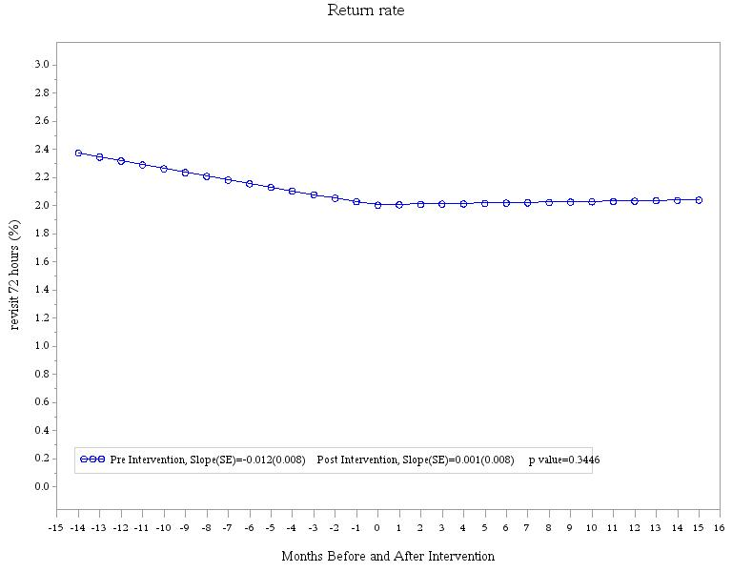

Y-axis title: 72-hour return rate (%)

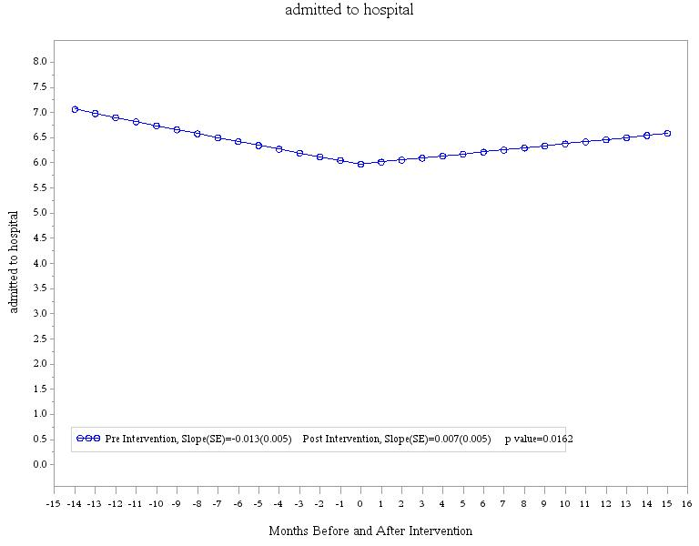

Y-axis title: Rate of admission to hospital (%)

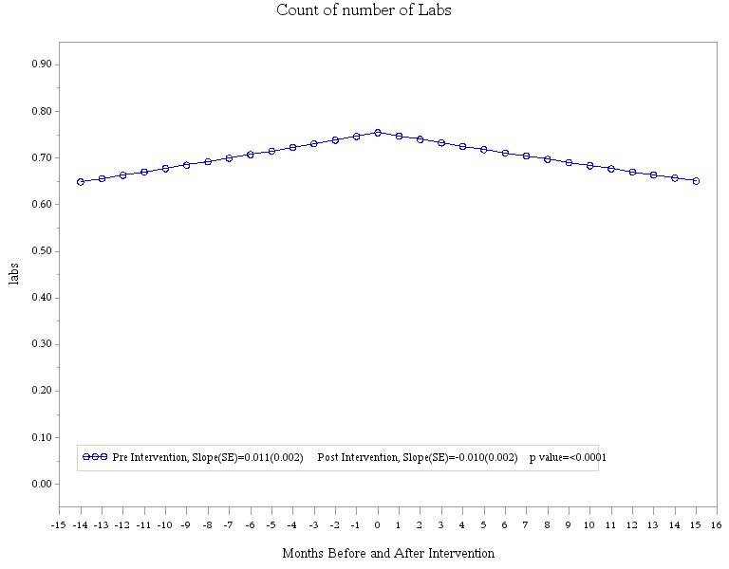

Y-axis title: Lab tests performed (per patient)

*Change the scale to ‘per 100 patients’?*

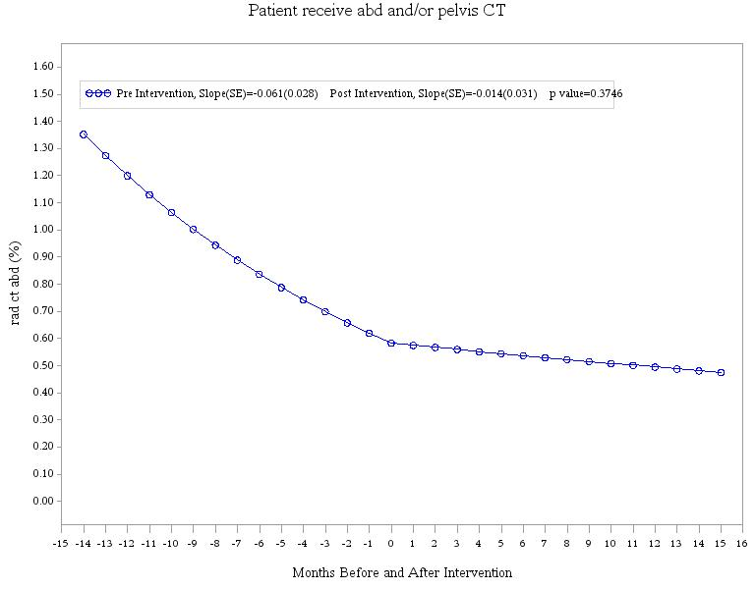

Y-axis title: Abdominal/pelvic CT scans performed (%)

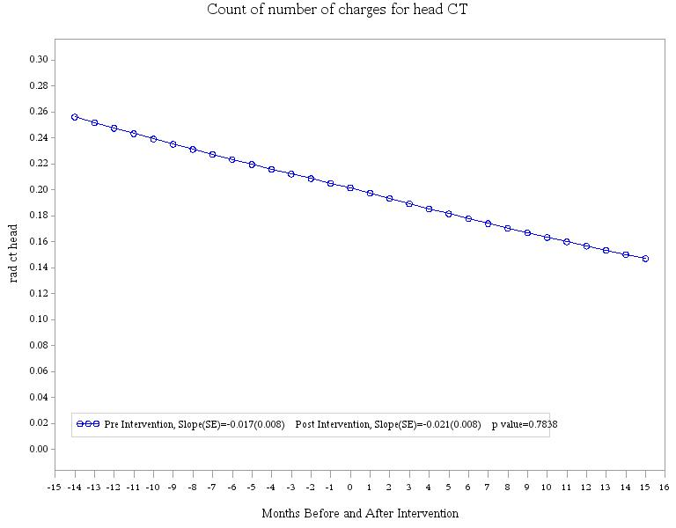

Y-axis title: Head CT scans performed (%)

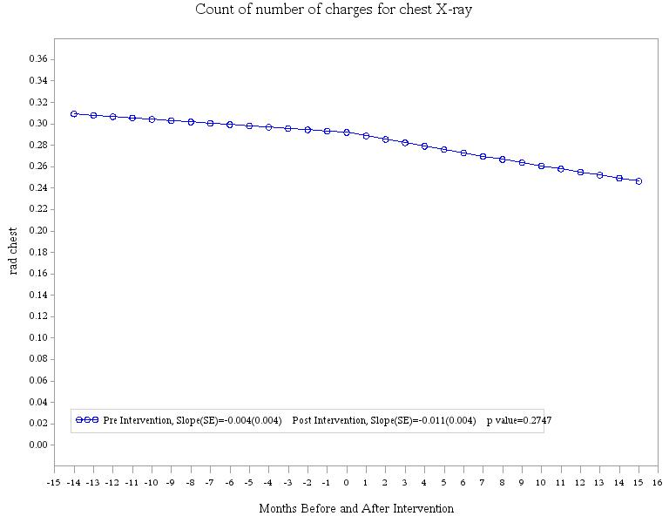

Y-axis title: Chest x-rays performed (per patient)

*Same as for lab graph above: change scale to ‘per 100 patients’?*

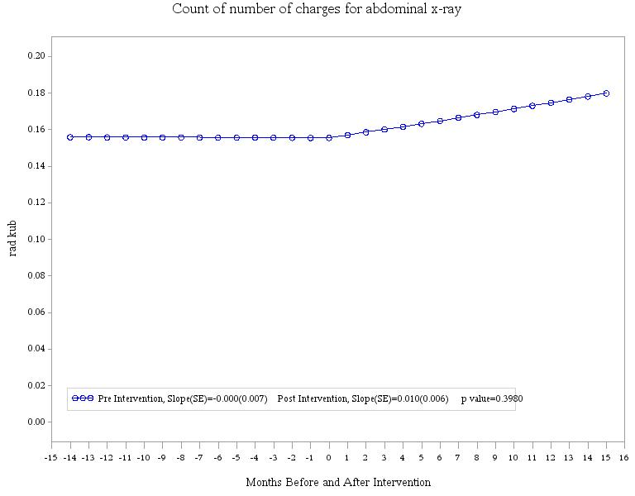

Y-axis title: Abdominal x-rays performed (per patient)

*Same as above: change to per 100 patients?*

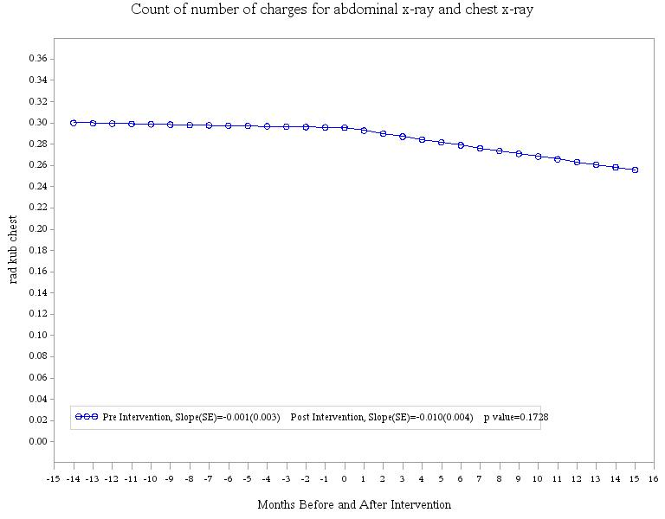

Y-axis title: Chest and abdominal x-rays performed (per patient)

*As above: change scale to ‘per 100 patients’?*

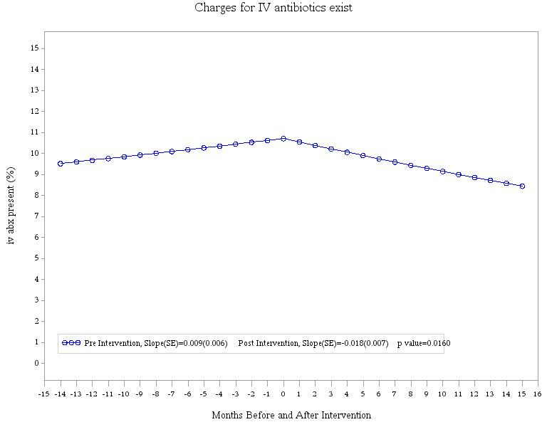

Y-axis title: Intravenous antibiotics administered (%)

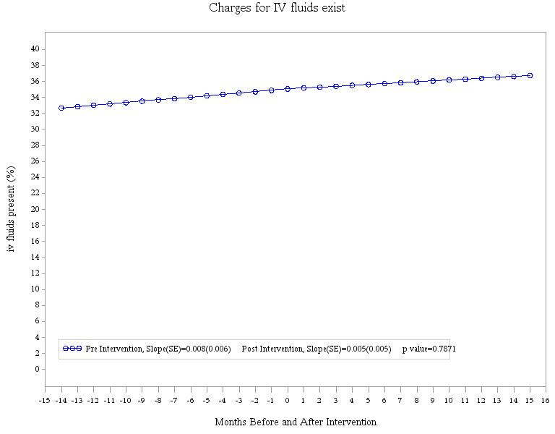

Y-axis title: Intravenous fluid administered (%)

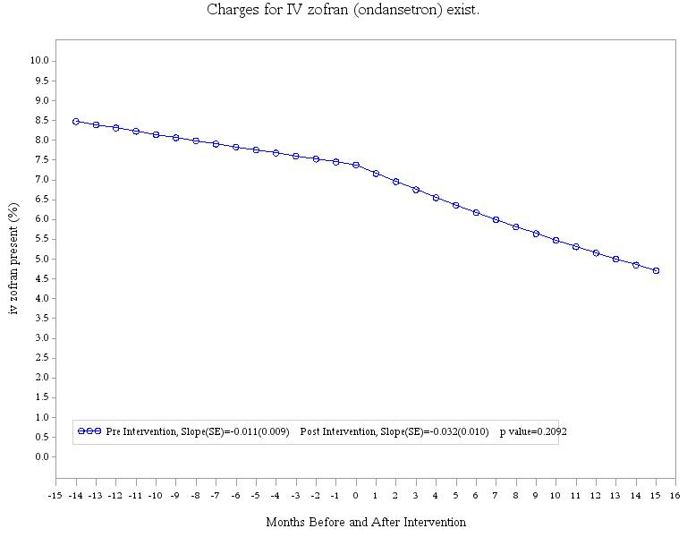

|  |
| --- |
|  |

Y-axis title: Intravenous ondansetron administered (%)